Task 1: Create One IAM User and Assign EC2 & S3 Full Access
Objective
To create a separate AWS IAM user and grant permissions to manage EC2 instances and S3 buckets without using the root account.
Why Are We Doing This?
- AWS recommends not using the root account for daily activities.
- IAM allows controlled access to AWS services.
- This follows security best practices in cloud environments.
Expected Outcome
After completing this task:
- One IAM user will be created.
- The user can log in to AWS Console.
- The user will have full access to EC2 and S3 services.

Step 1: Login to AWS Root Account
- Open AWS Console.
- Login using your root account.
Search for IAM in the search bar.
Click IAM.

Step 2: Create IAM User
- In IAM Dashboard click Users.
- Click Create User.
- Enter:
User name: devops-user
- Tick:
Provide user access to the AWS Management Console
- Select:
I want to create an IAM user
- Choose:
Custom Password
Example:
Devops@123
- Uncheck:
Users must create a new password at next sign-in
- Click Next.
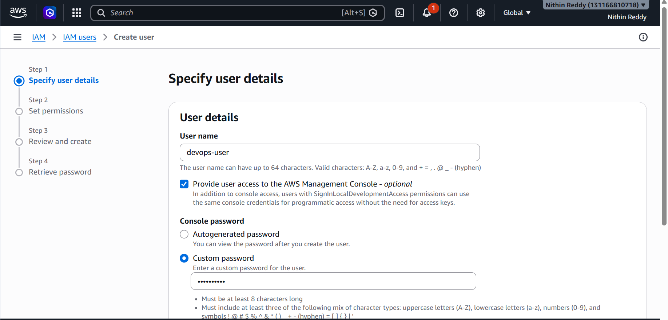
Step 3: Assign Permissions
Choose:
Attach policies directly
Search and select:
AmazonEC2FullAccess
Search and select:
AmazonS3FullAccess
Both policies should be checked.
Click:
Next
Then:
Create User
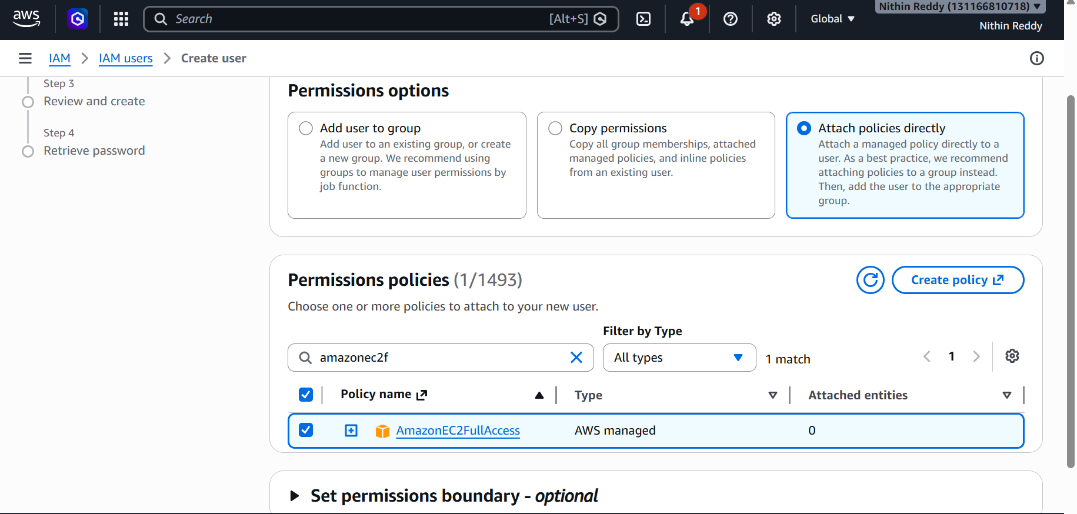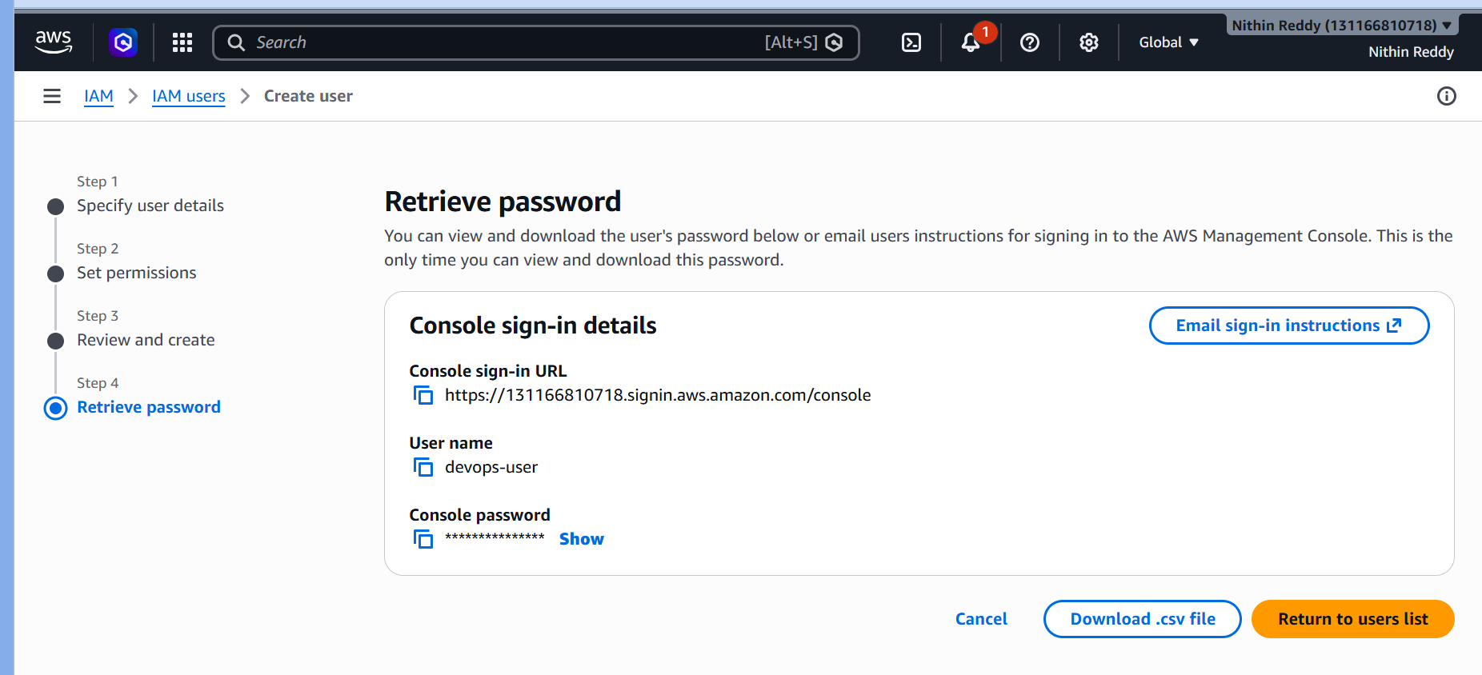
Step 4: Download Credentials
After user creation:
Click the newly created user.
Go to:
Security credentials
Note down:
Username
Password
Console Sign-in URL
Take Screenshot #1:
- IAM User Created
Take Screenshot #2:
- Attached Policies
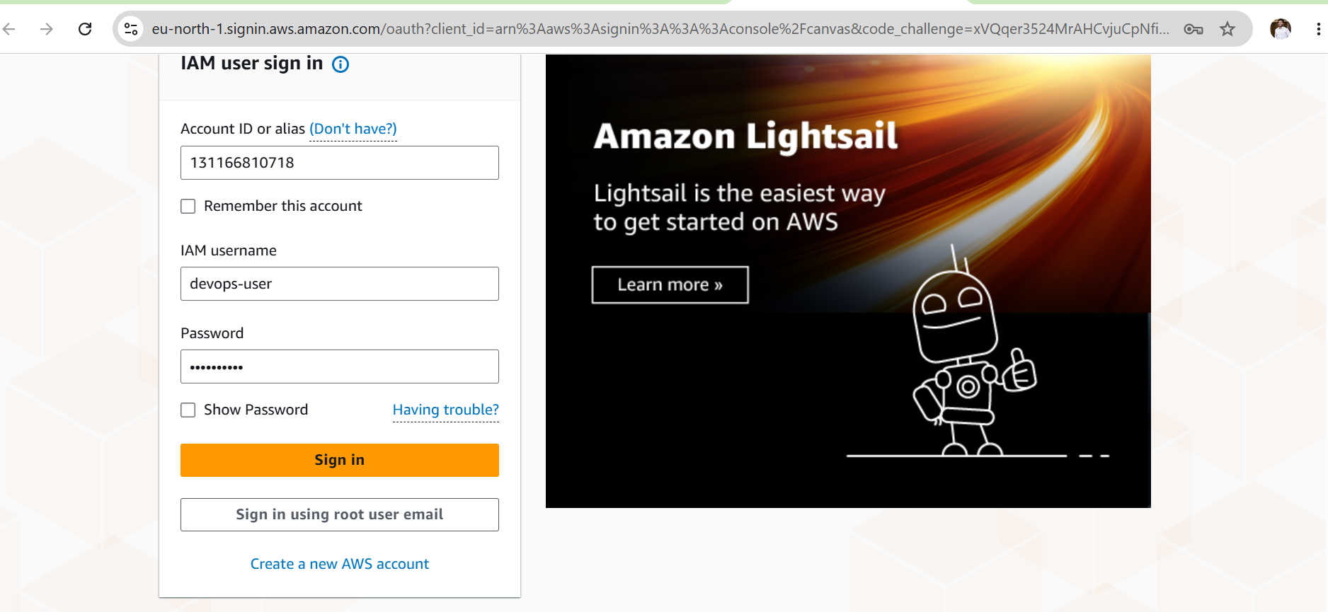
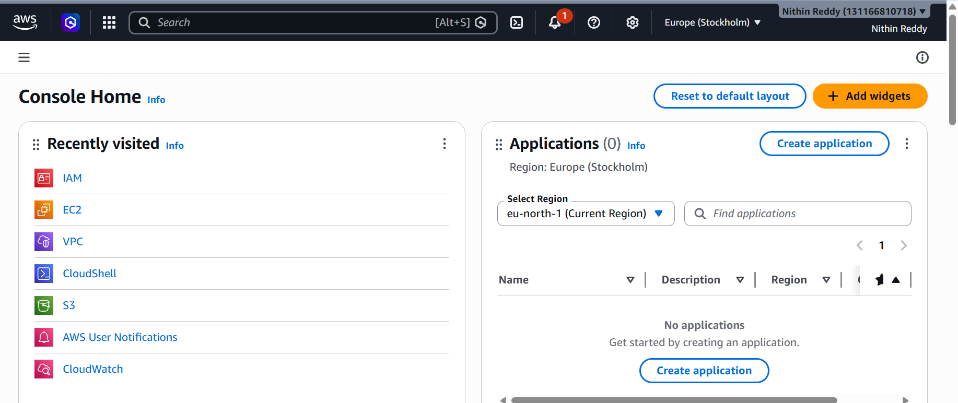
Validation Check 1
Open EC2 Service.
If EC2 Dashboard opens successfully:
✅ EC2 Access Working

Validation Check 2
Open S3 Service.
If S3 Dashboard opens successfully:
✅ S3 Access Working
Take Screenshot #3:
- EC2 Dashboard Opened
Take Screenshot #4:
- S3 Dashboard Opened

Common Errors & Fixes
Error 1
You are not authorized to perform this operation
Fix
Check whether:
AmazonEC2FullAccess
AmazonS3FullAccess
are attached to the user.

Error 2
Invalid username or password
Fix
Reset password:
IAM → Users → devops-user → Security Credentials → Reset Password

Error 3
Cannot find IAM login URL
Fix
IAM Dashboard → Account Alias → Copy Sign-In URL.

Task 2: Create One IAM Group and Assign Read Access for EC2
Objective
Create an IAM Group and grant EC2 read-only permissions so that users in the group can view EC2 resources but cannot create, modify, or delete them.
Why Are We Doing This?
- Groups help manage permissions for multiple users.
- Instead of assigning permissions to users one by one, permissions can be managed through groups.
- Follows Role-Based Access Control (RBAC) principles.
Expected Outcome
After completing this task:
- An IAM Group will be created.
- The group will have EC2 read-only access.
- Any user added to the group can view EC2 resources.
Step 1: Open IAM Groups
- Login to AWS Console.
- Open IAM.
- In the left menu click User groups.
- Click Create group.

Step 2: Create Group
Enter:
Group name: EC2-ReadOnly-Group
Click Next.
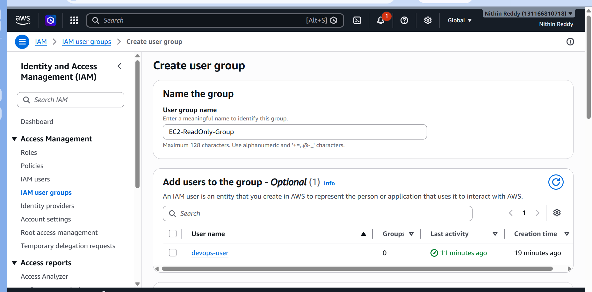
Step 3: Assign Permission
Search for:
AmazonEC2ReadOnlyAccess
Select the policy.
Click:
Next
Review and click:
Create group
Take Screenshot #1:
- Group Creation Page
Take Screenshot #2:
- Group Successfully Created
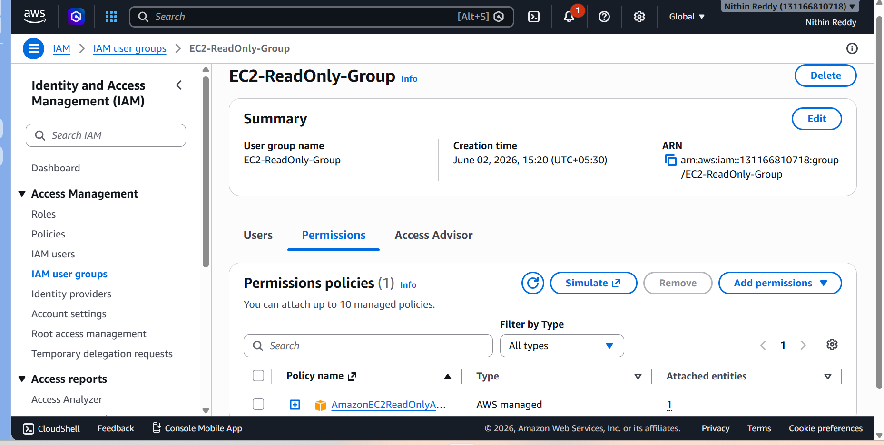
Step 4: Verify Attached Policy
- Open the newly created group.
- Go to Permissions tab.
You should see:
AmazonEC2ReadOnlyAccess
Take Screenshot #3:
- Group Permissions
Step 5: Add Existing IAM User to Group (Recommended Validation)
- Open the group.
- Click Add users.
- Select:
devops-user
- Click Add users.
Take Screenshot #4:
- User Added to Group
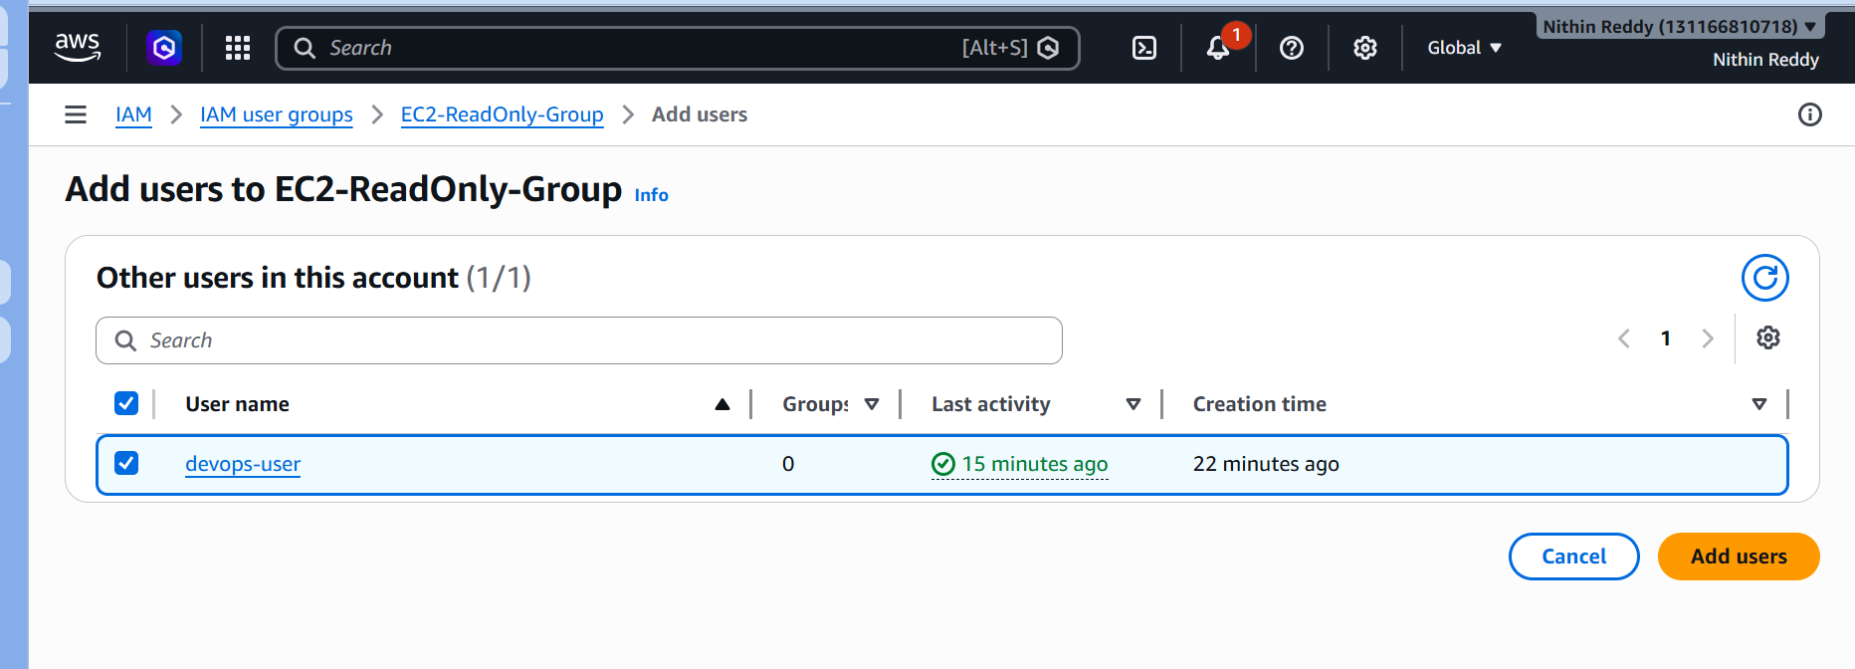
Validation Test
Try clicking:
Launch Instance
If permission is denied (or if only read access is available through this group's policy), the read-only permission is working as intended.
Note: Group created
- Read-only policy attached
- User added to group
Common Errors & Fixes
Error: Policy Not Found
Search exactly:
AmazonEC2ReadOnlyAccess
Error: Cannot Add User
Ensure the IAM user (devops-user) exists and is active.

Task 3: Create a New User "Devops" and Add to the Group
Objective
Create a new IAM user named Devops and assign the permissions inherited from the IAM group created in Task 2.
Why Are We Doing This?
- Demonstrates permission management through groups.
- Users automatically inherit permissions from groups.
- Makes permission administration easier in large organizations.
Expected Outcome
After completion:
- IAM user Devops is created.
- User is added to EC2-ReadOnly-Group.
- User receives EC2 read-only access through the group.
Step 1: Open IAM Users
- Login to AWS Console.
- Open IAM.
- Click Users.
- Click Create User.
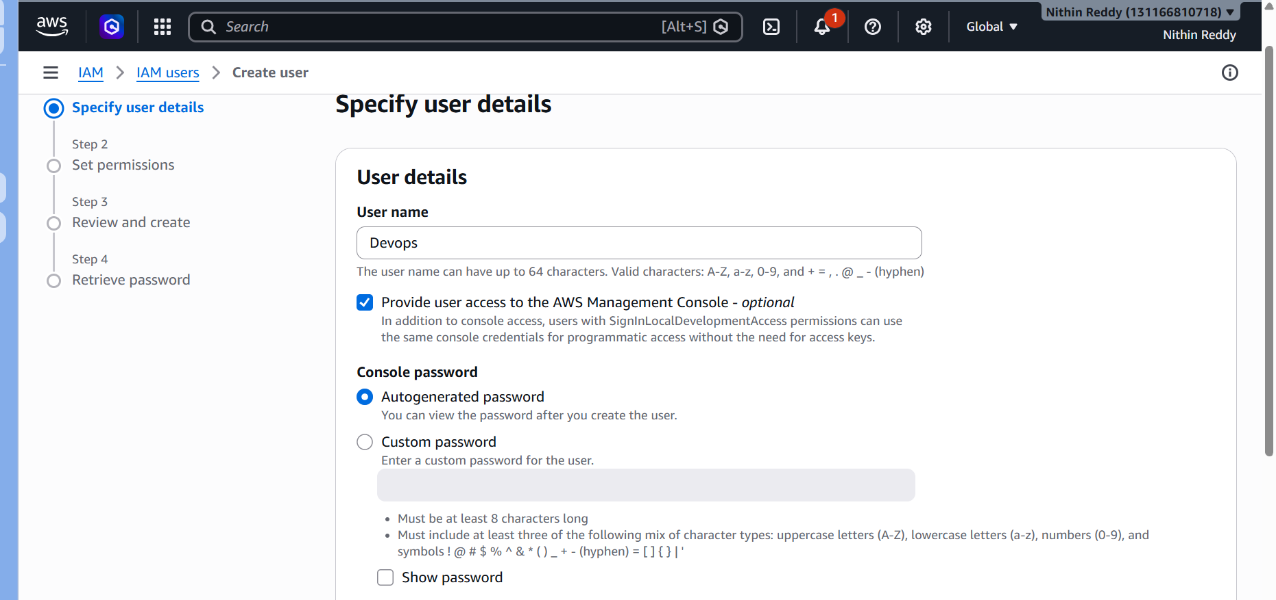
Step 2: Create User
Enter:
User name: Devops
Enable:
Provide user access to AWS Management Console
Choose:
I want to create an IAM user
Create a password:
Devops@123
(Optional: Use any password that meets AWS requirements.)
Click Next.
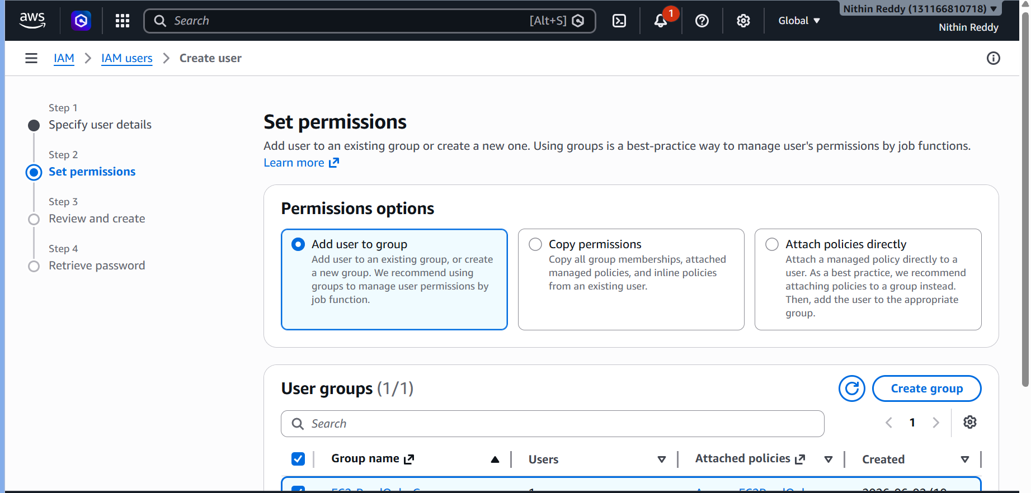
Step 3: Add User to Existing Group
Choose:
Add user to group
Select:
EC2-ReadOnly-Group
Click:
Next
Then:
Create User
Take Screenshot #1:
- User Creation Page
Take Screenshot #2:
- User Successfully Created
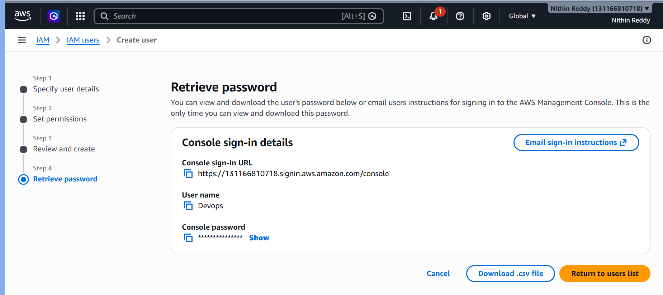
Step 4: Verify Group Membership
- Open IAM → Users.
- Click Devops.
- Go to Groups tab.
You should see:
EC2-ReadOnly-Group
Take Screenshot #3:
- User Group Membership
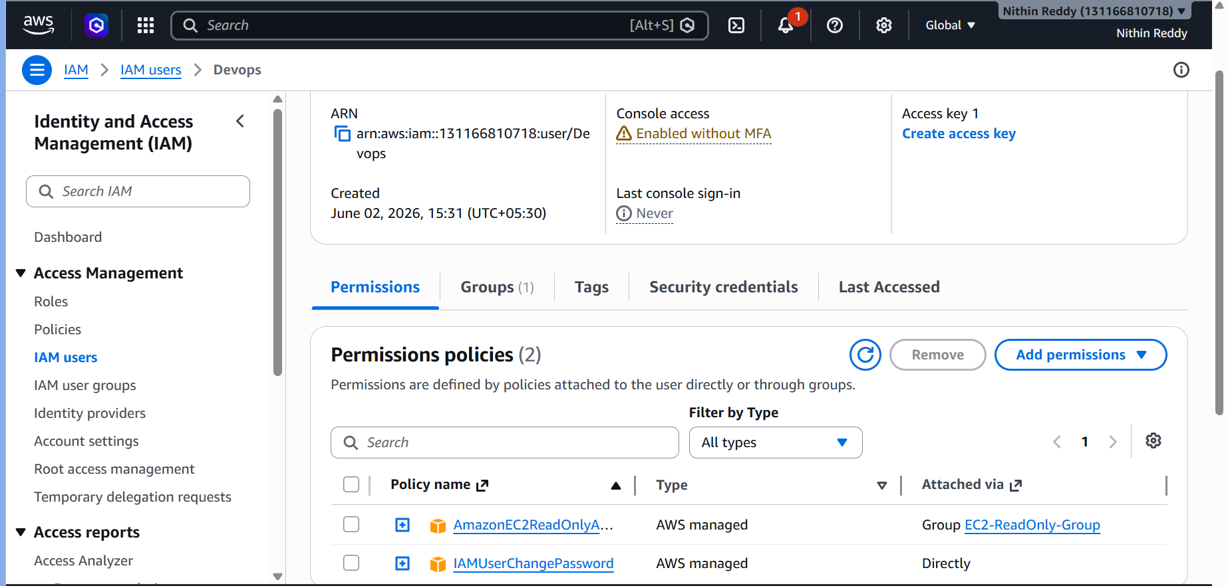
Step 5: Validation
Logout.
Login using the Devops user credentials.
Open EC2 Dashboard.
Expected behavior:
✅ Can view EC2 resources.
❌ Cannot launch or terminate instances.
This confirms the user inherited permissions from the group.
Take Screenshot #4:
- EC2 Dashboard Opened with Devops User

Common Errors & Fixes
Error: Group Not Visible
Verify that EC2-ReadOnly-Group was created successfully in Task 2.

Error: User Already Exists
AWS IAM usernames must be unique.
If "Devops" already exists:
Devops1
or
Devops-user
can be used, but use Devops if available because the task specifically requests that name.

Error: Login Failed
Check:
- IAM Login URL
- Username spelling
- Password
Reset the password if necessary.

Task 4: Write a Bash Script to Create an IAM User with VPC Full Access
Objective
Create an IAM user automatically using a Bash script and assign VPC Full Access permissions.
Why Are We Doing This?
- Automation is a key DevOps skill.
- Eliminates manual user creation.
- Ensures consistency and saves time.
Expected Outcome
After execution:
- IAM user is created.
- VPC Full Access policy is attached.
- User appears in IAM Console.

Prerequisites
Verify AWS CLI is installed:

Steps Performed
- Created a Bash script file.
cat > create-vpc-user.sh
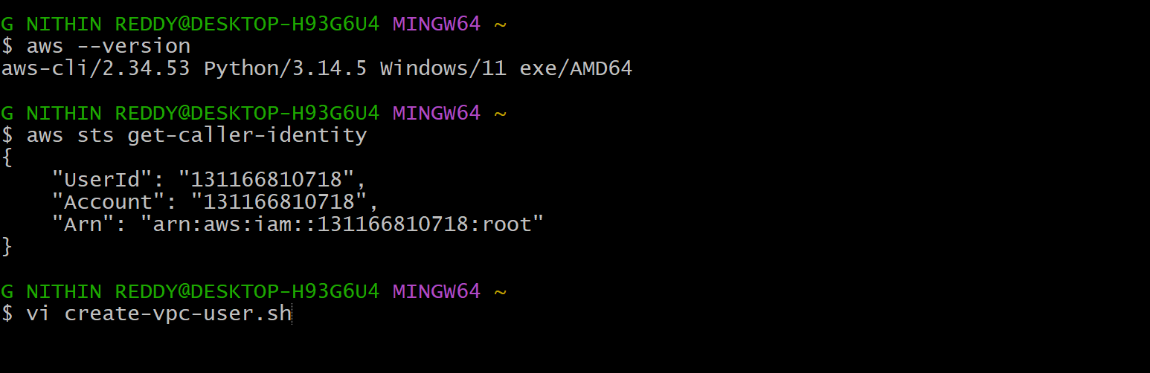
- Added commands to:
  - Create IAM user.
  - Attach AmazonVPCFullAccess policy.
- Provided execute permission to the script.
chmod +x create-vpc-user.sh
- Executed the script.
./create-vpc-user.sh
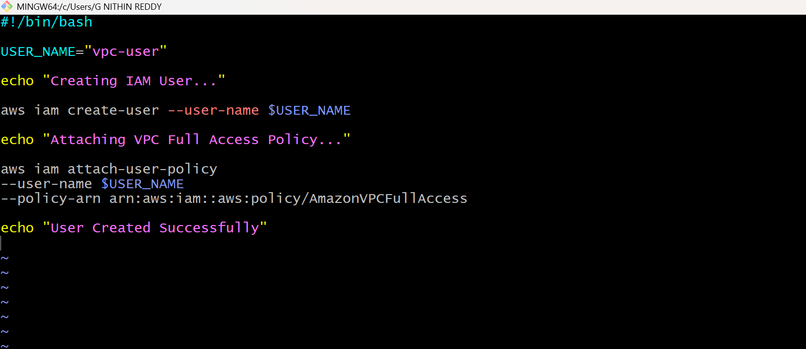

- Verified IAM user creation.
aws iam get-user --user-name vpc-user
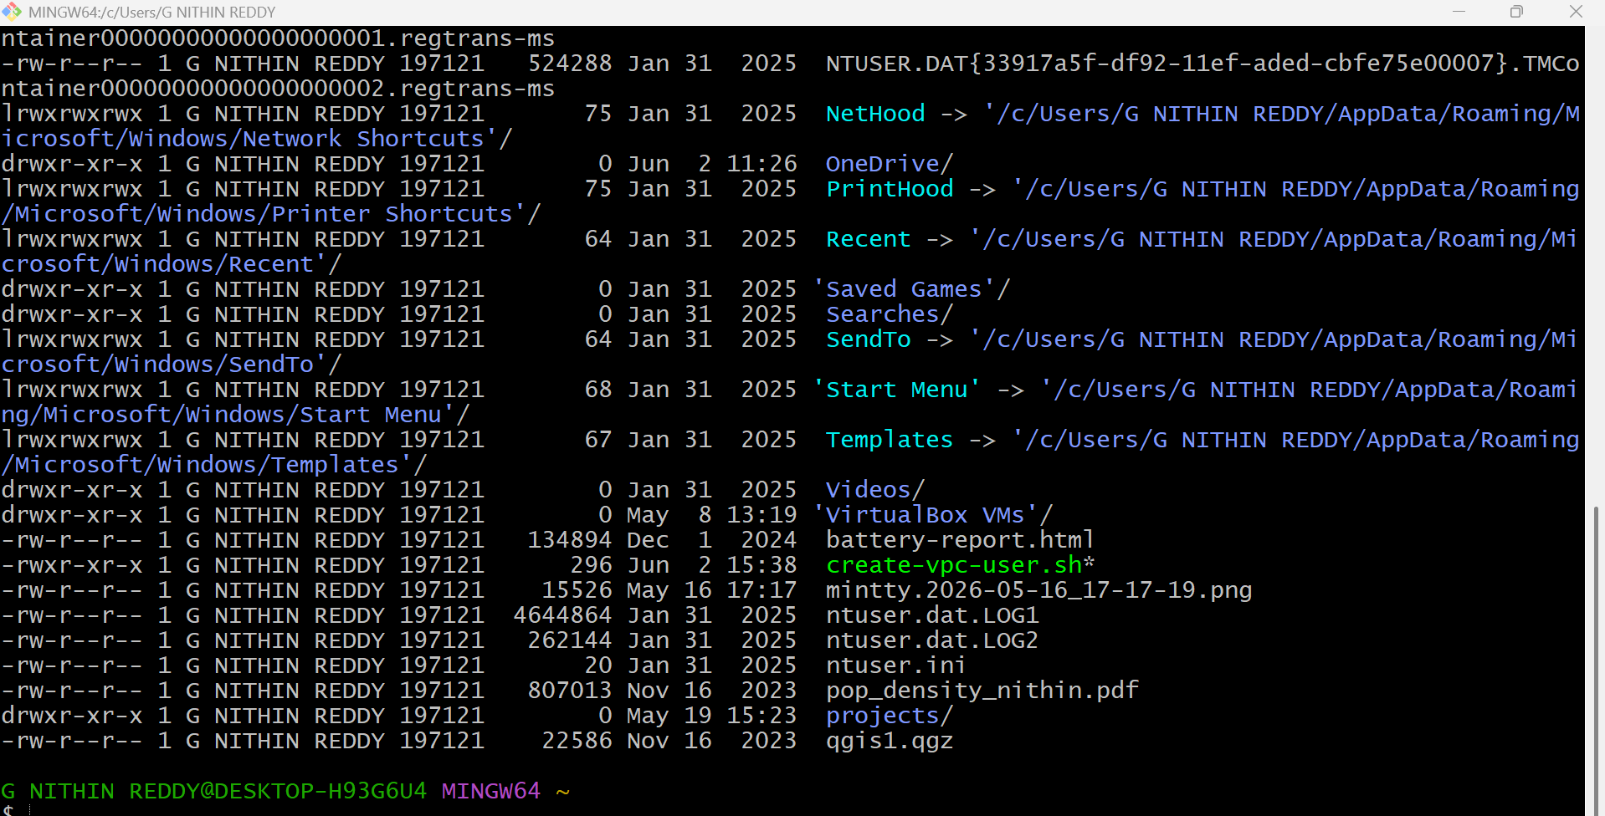
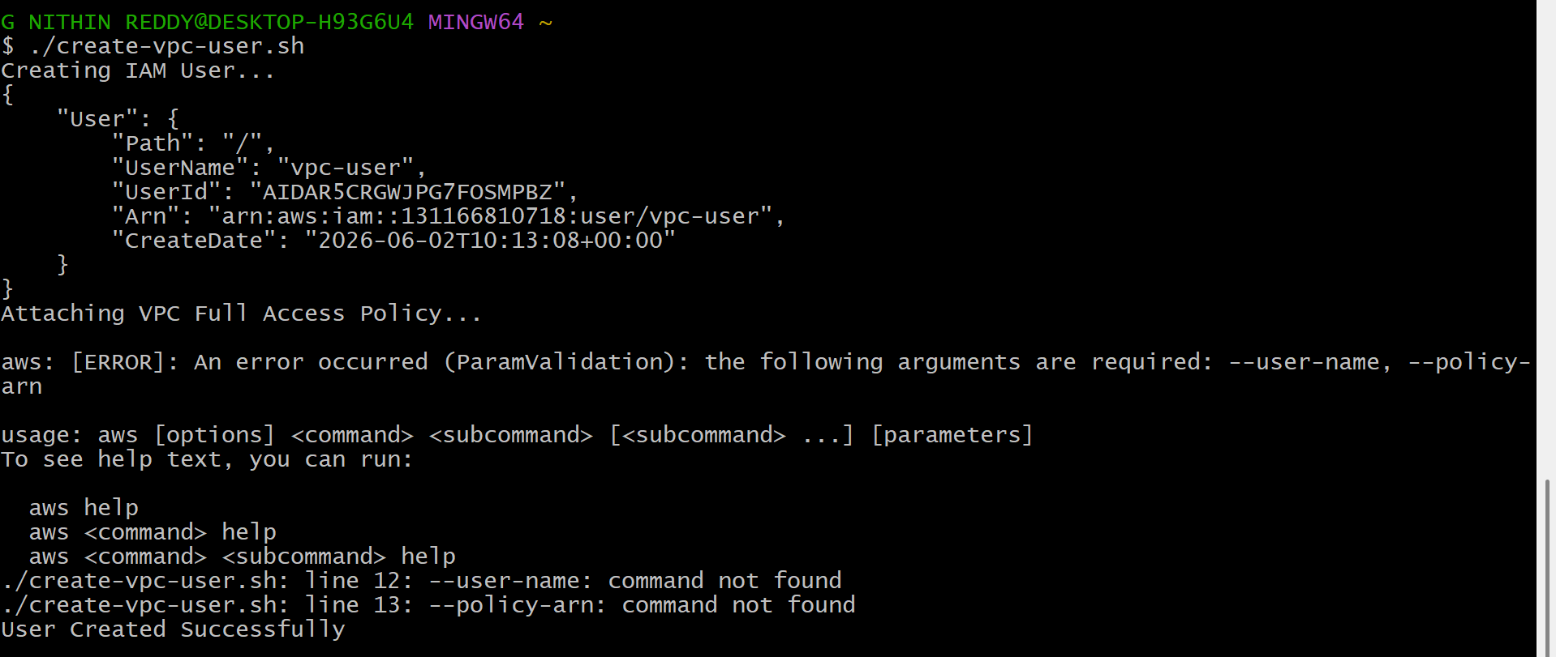

- Verified policy attachment.
aws iam list-attached-user-policies --user-name vpc-user
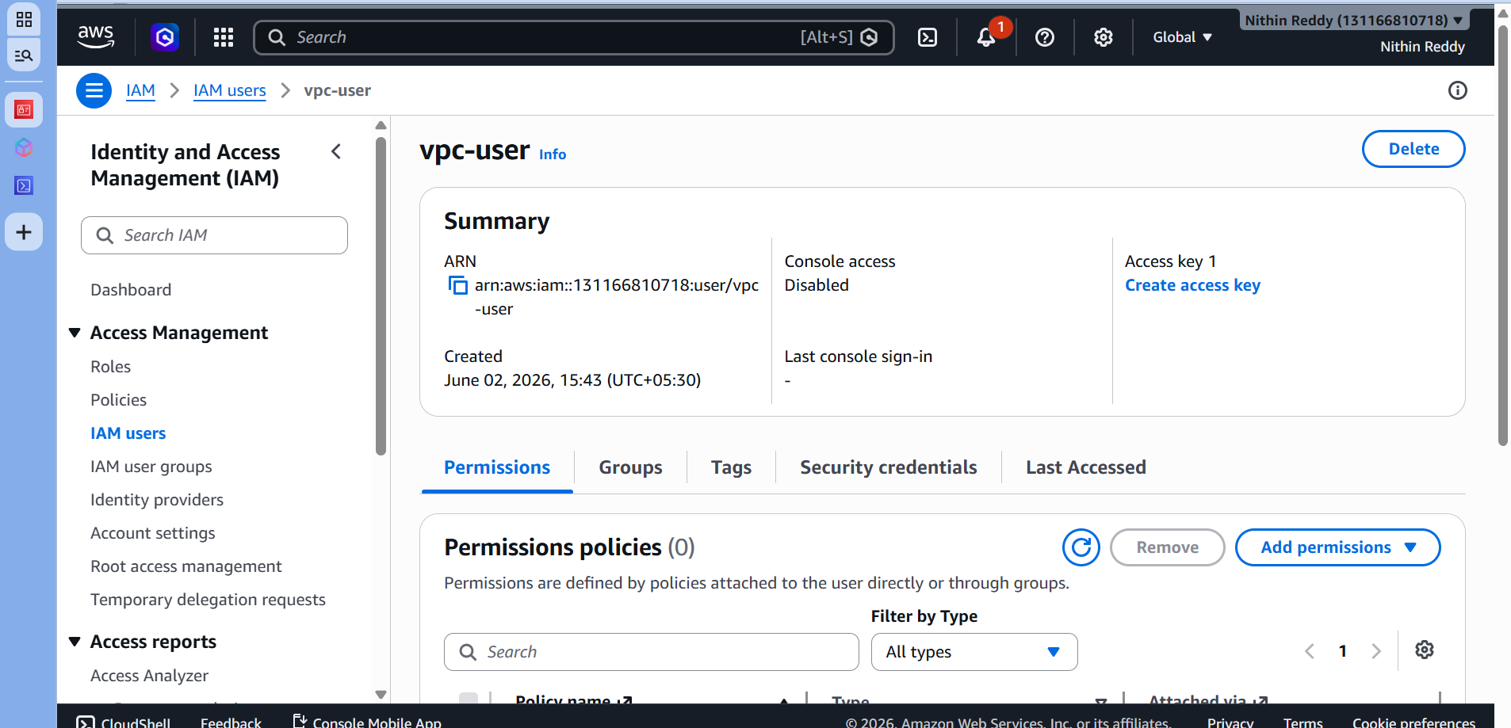
Validation
- Confirmed vpc-user was created successfully.
- Confirmed AmazonVPCFullAccess policy was attached to the user.
- Verified the same in AWS IAM Console.

Evidence Collected
- Script content screenshot.
- Script execution output.
- IAM user verification output.
- Attached policy verification output.
- IAM Console screenshot showing VPC Full Access permission.

Troubleshooting
Issue: EntityAlreadyExists
Resolution: User already existed; proceeded with policy attachment and verification.
Issue: Policy not attached initially.
Resolution: Executed the attach-policy command manually and verified successful attachment.

Task 5: Create an IAM Policy to Allow EC2 Access Only in Specific Regions
Objective
Create a custom IAM policy that allows a user to work with EC2 only in a specified AWS Region (for example, Mumbai - ap-south-1).
Why Are We Doing This?
- Restricts access based on AWS Region.
- Improves security and governance.
- Common real-world enterprise requirement.
Expected Outcome
- Custom IAM policy created.
- Policy attached to a specific IAM user.
- User can access EC2 only in the allowed region.

Step 1: Create Policy
Go to:
IAM → Policies → Create Policy
Select:
JSON
Paste this policy:
{
"Version": "2012-10-17",
"Statement": [
{
"Sid": "EC2AccessMumbaiOnly",
"Effect": "Allow",
"Action": "ec2:",
"Resource": "",
"Condition": {
"StringEquals": {
"aws": "ap-south-1"
}
}
}
]
}
Click:
Next
Policy Name:
EC2-Mumbai-Only-Policy
Click:
Create Policy
Take Screenshot #1:
- Policy JSON
Take Screenshot #2:
- Policy Created
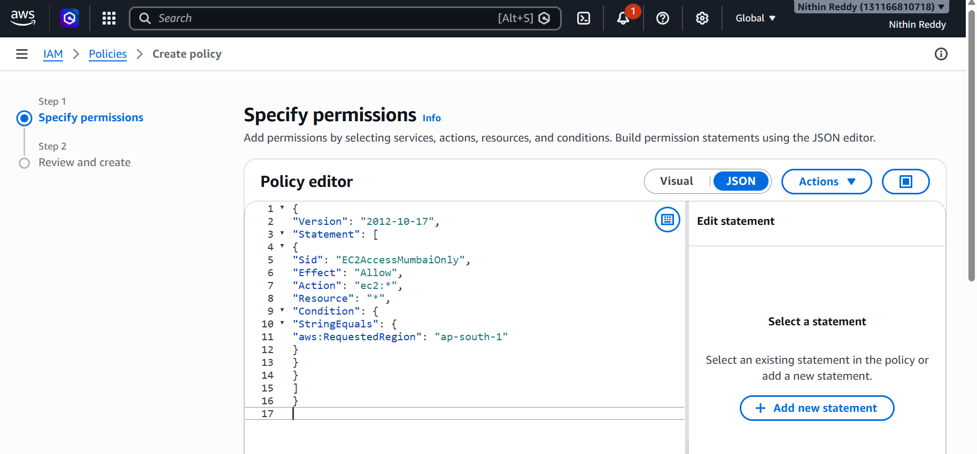
Step 2: Attach Policy to User
Go to:
IAM → Users → Devops
Click:
Add Permissions
Choose:
Attach Policies Directly
Select:
EC2-Mumbai-Only-Policy
Click:
Add Permissions
Take Screenshot #3
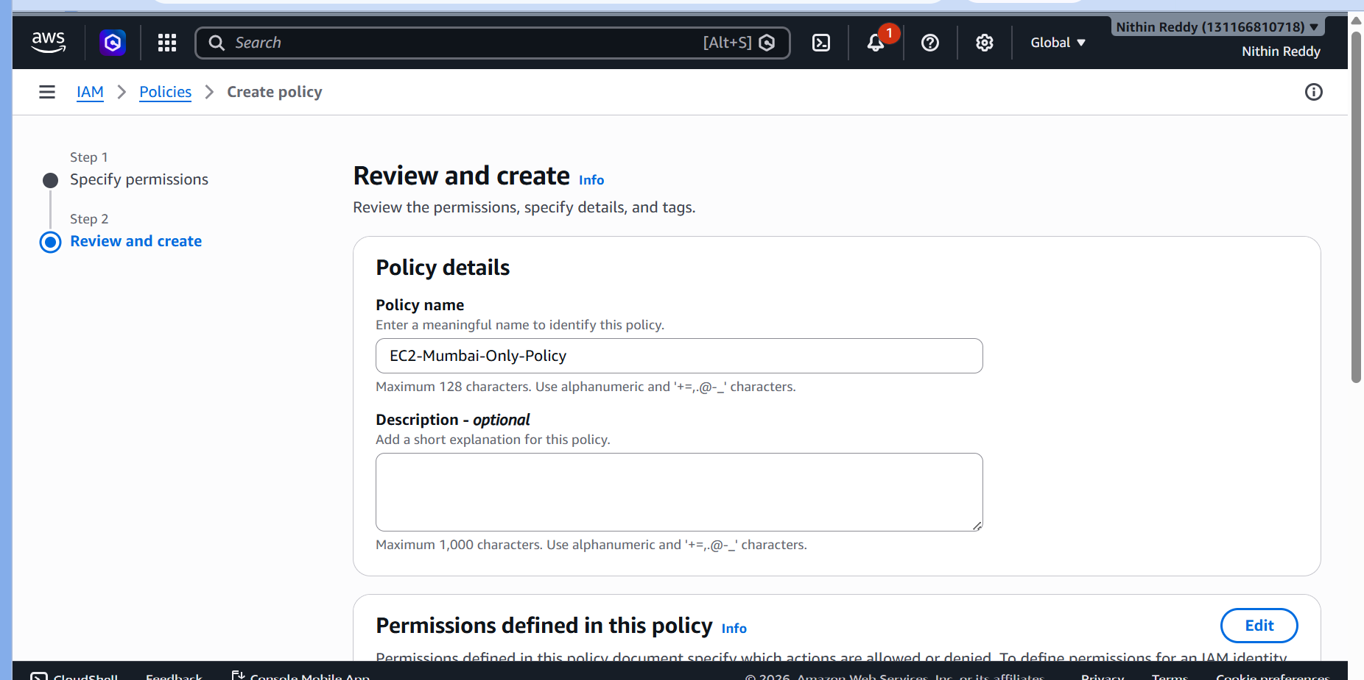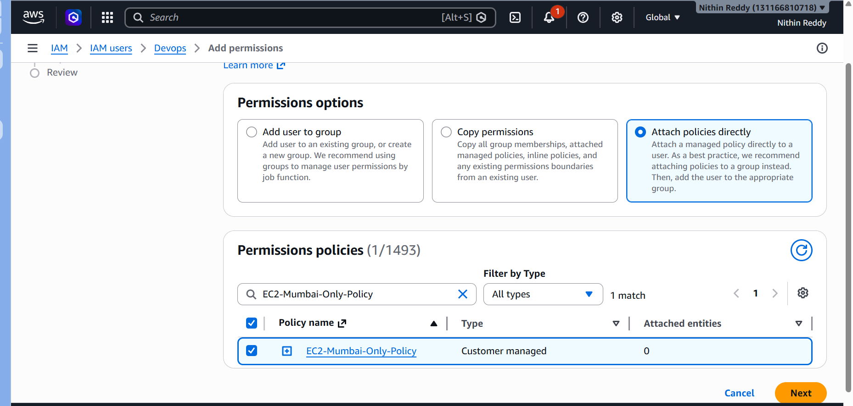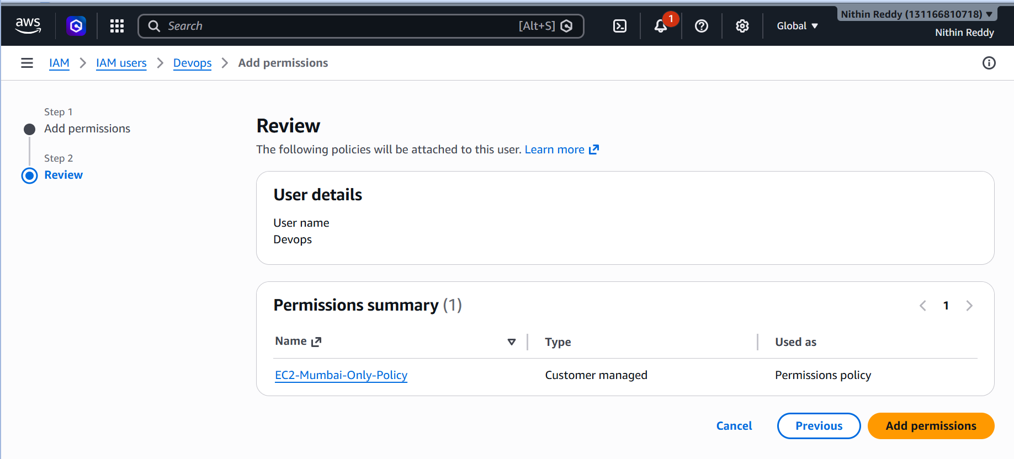

Step 3: Validation
Login as Devops user.
Switch Region:
Mumbai (ap-south-1)
Open EC2.
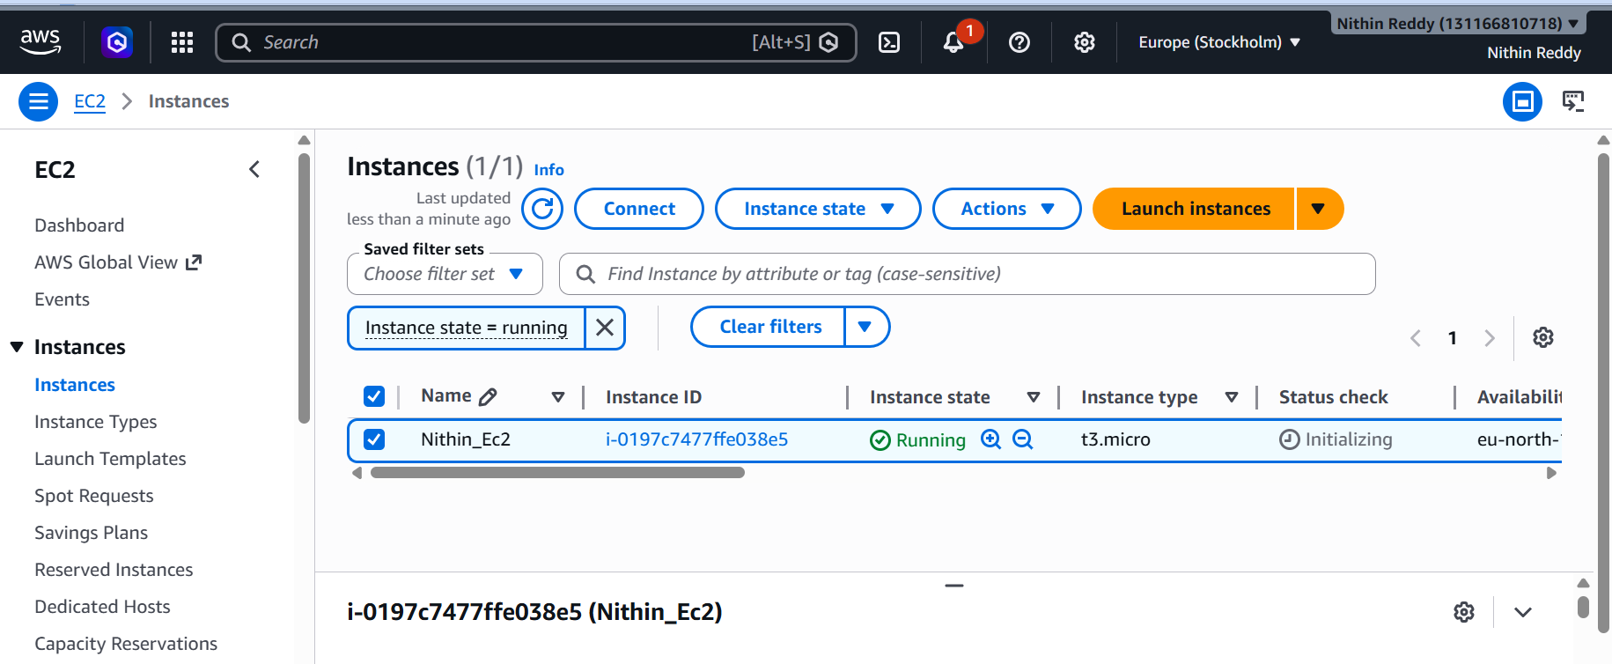
✅ Access should work.
Now switch to:
US East (N. Virginia)
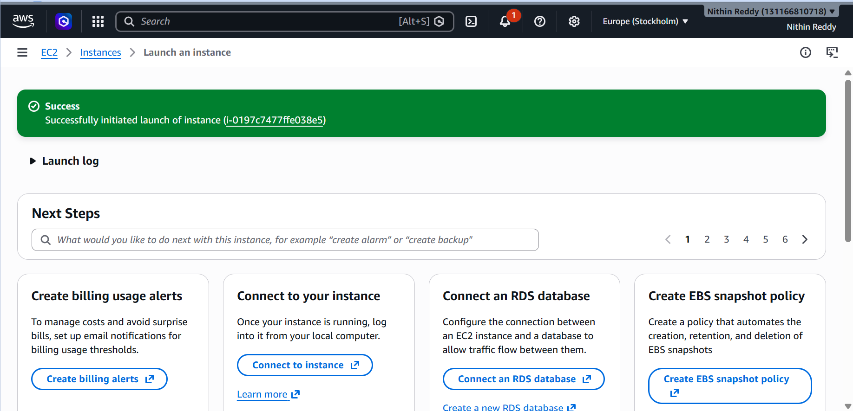

Open EC2.
❌ Access should be restricted or operations should fail.
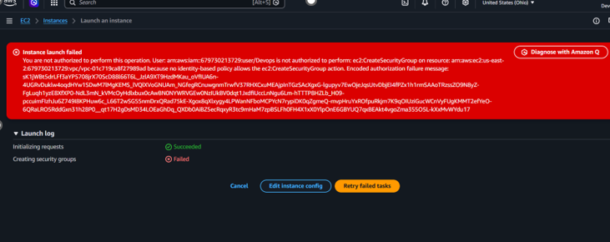
Short Submission Notes
Objective
Create a custom IAM policy that restricts EC2 access to a specific AWS Region.
Outcome
Successfully created and attached a custom IAM policy allowing EC2 access only in the Mumbai (ap-south-1) region.
Validation
Verified that EC2 access works in the allowed region and is restricted outside the specified region.

Task 6: Allow Account A User to Access an S3 Bucket in Account B
Objective
Allow an IAM user from Account A to access an S3 bucket located in Account B.
Why Are We Doing This?
- Share resources securely across AWS accounts.
- Common in multi-account AWS environments.
- Frequently asked in AWS and DevOps interviews.
Expected Outcome
- S3 bucket exists in Account B.
- IAM user exists in Account A.
- User from Account A can access the bucket in Account B.

Prerequisites
Account A
Create an IAM user:
accountA-user
Account B
Create an S3 bucket:
cross-account-demo-bucket
(Use a unique bucket name if needed.)
Collect:
Account A ID
Account B ID
Bucket Name
IAM User Name
Steps Performed:
- Created an S3 bucket in Account B.
Bucket Name: crossaccount-demo-bucket-nithin
- Uploaded a sample file into the S3 bucket.
- Created/identified an IAM user in Account A.
- Created and attached an IAM policy to the user in Account A with:
  - s3
  - s3
- Configured a Bucket Policy in Account B allowing access to Account A.
- Saved and validated both policies.
- Logged in using the IAM user from Account A.
- Accessed the S3 bucket and verified object visibility.
- Downloaded the object successfully using AWS Console/AWS CLI.

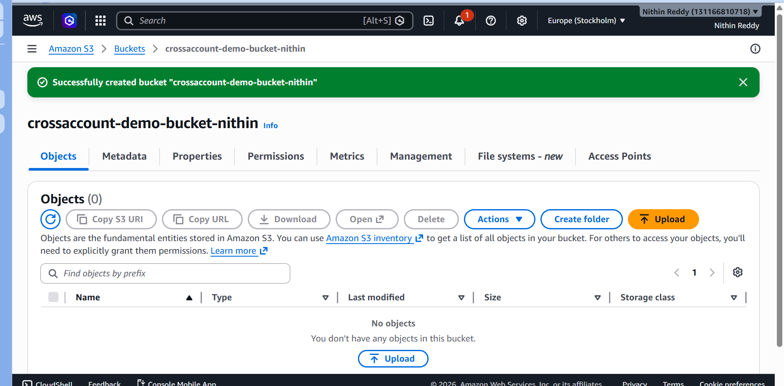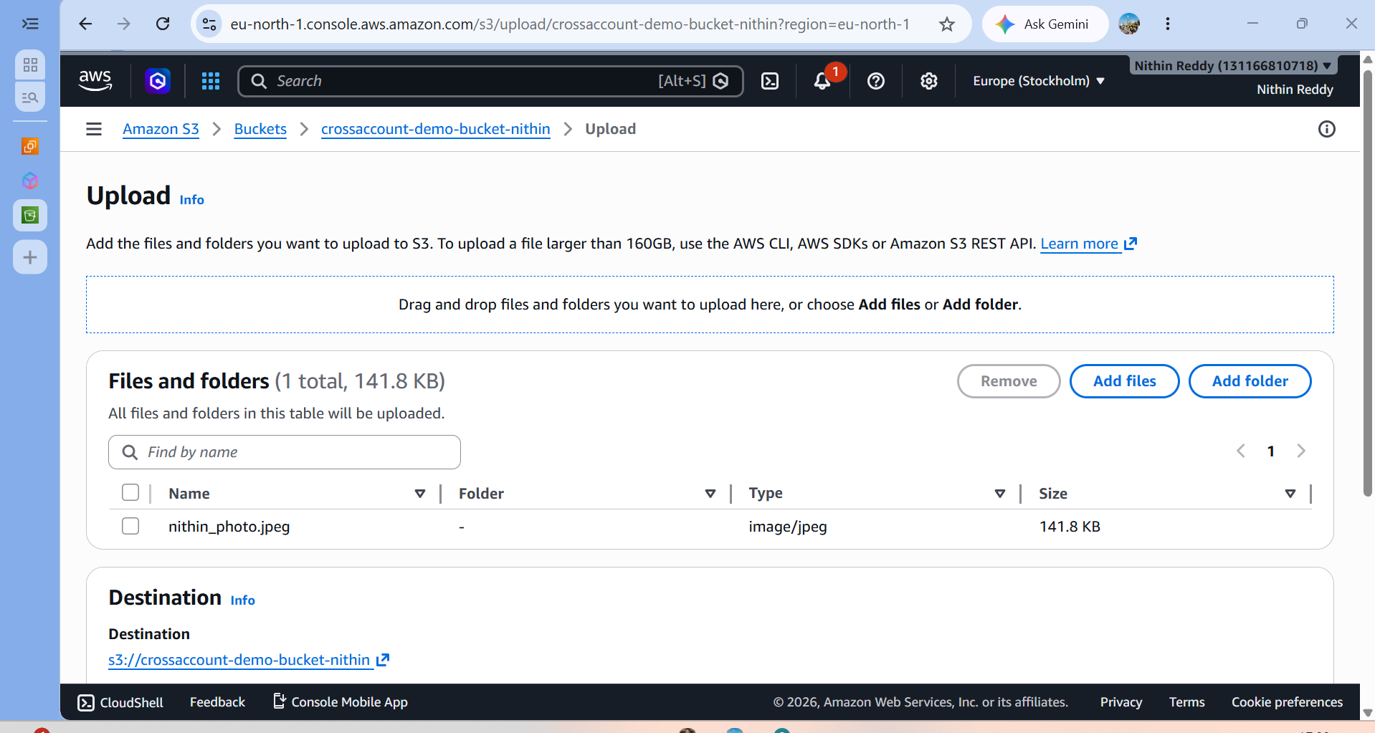

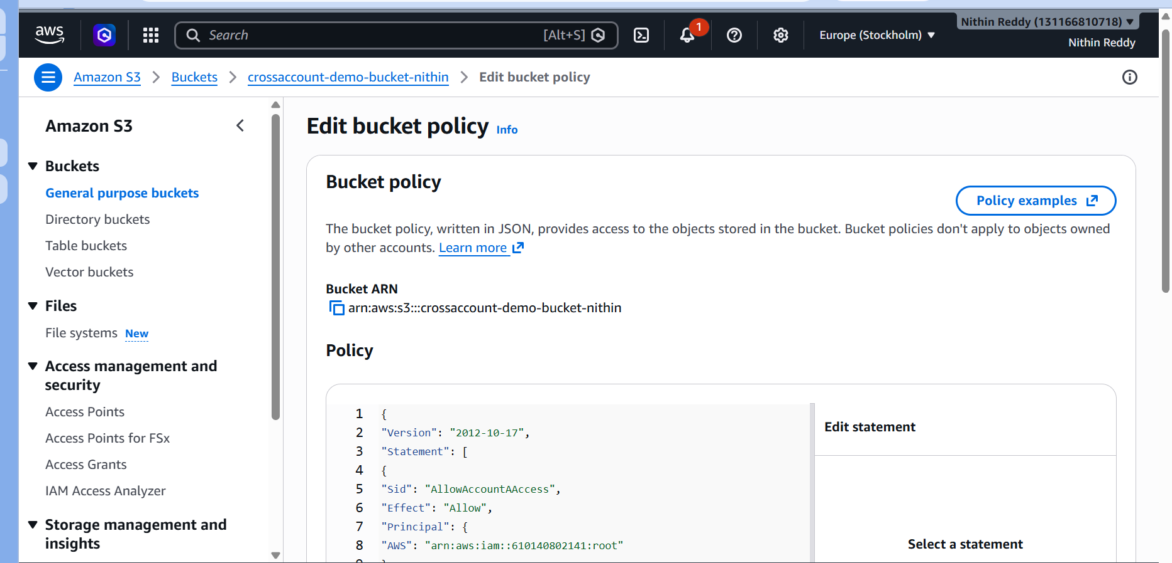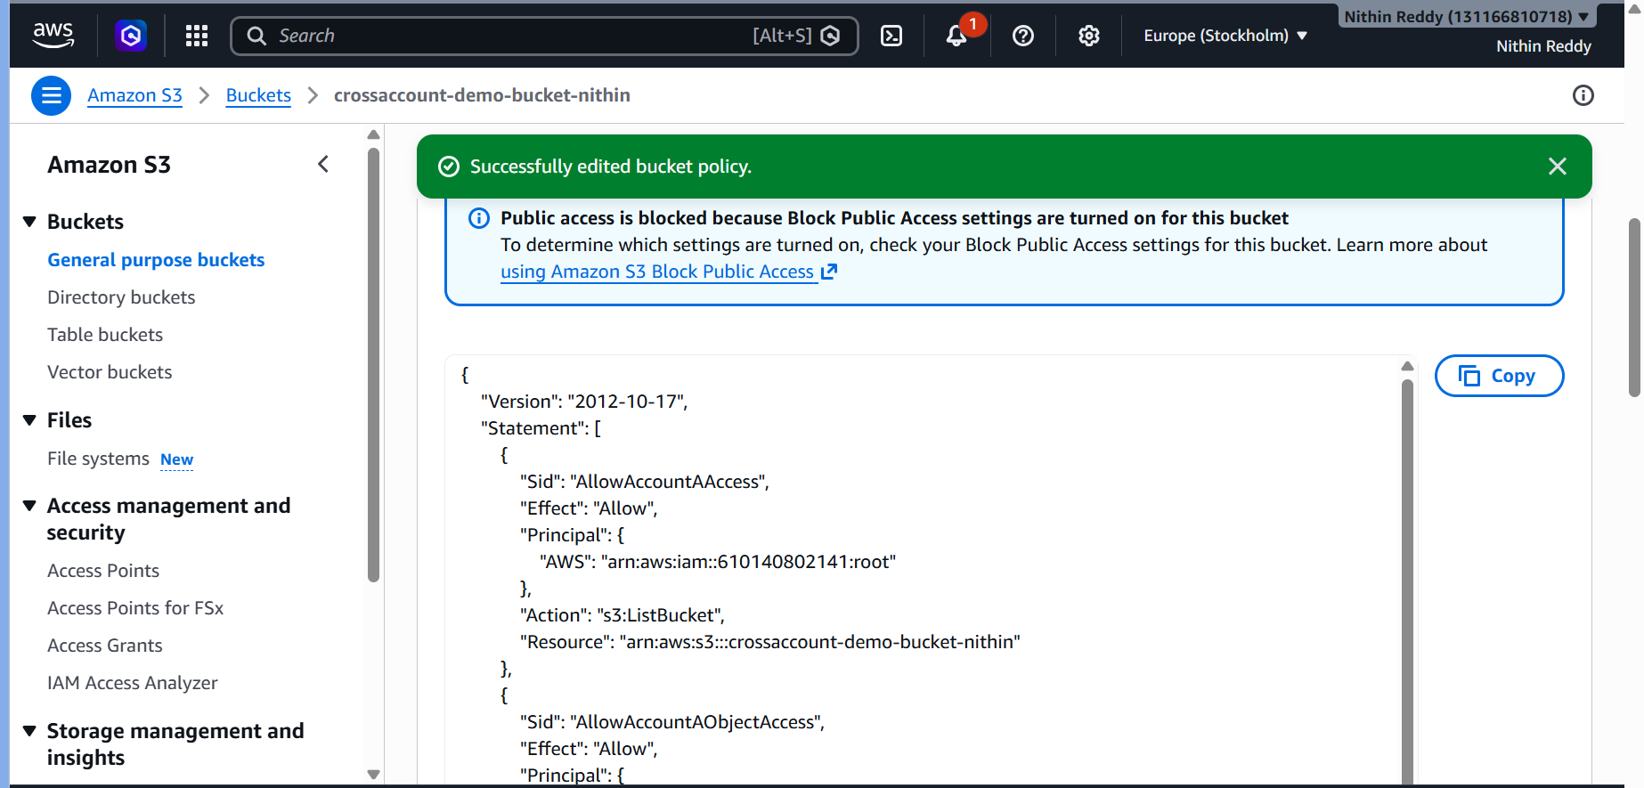
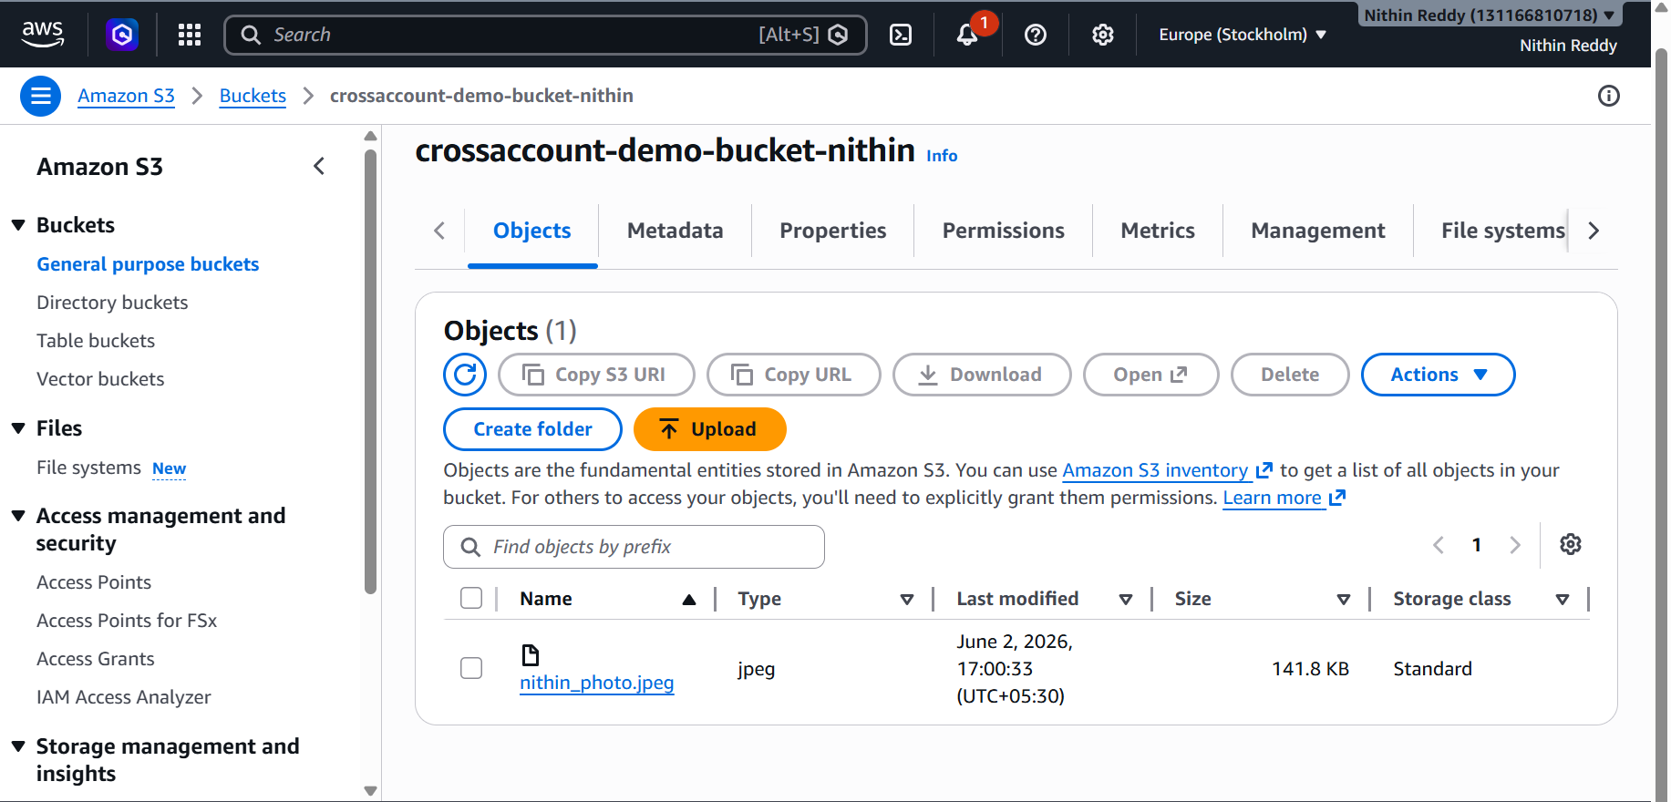
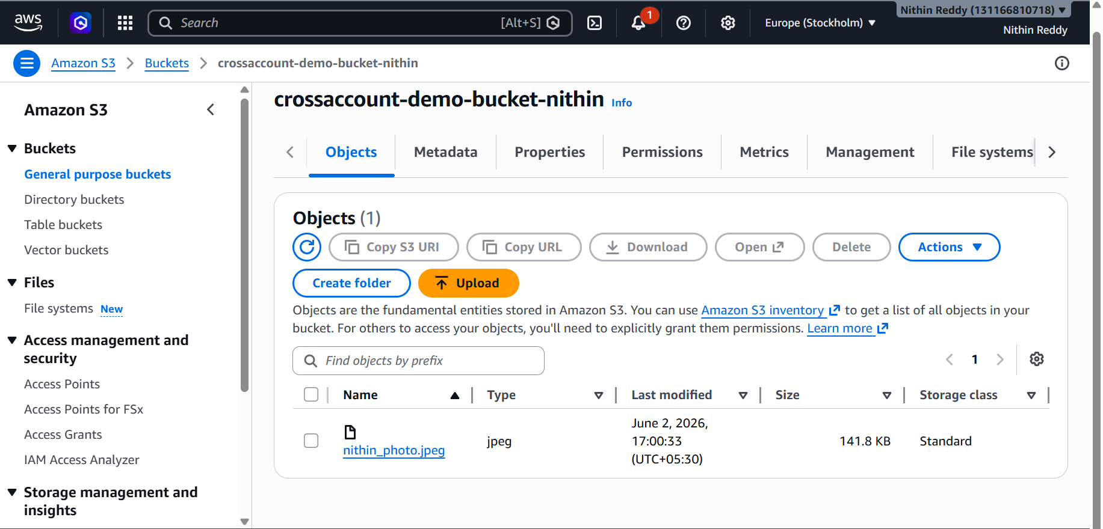
Validation:
- Verified S3 bucket was accessible from Account A.
- Verified uploaded file was visible.
- Verified file download was successful.
- Verified no Access Denied errors were encountered after policy configuration.
Evidence Collected:
- S3 Bucket Creation Screenshot.
- Uploaded File Screenshot.
- IAM User Screenshot.
- IAM Policy Screenshot.
- Bucket Policy Screenshot.
- Successful Cross-Account Access Screenshot.
- File Download Verification Screenshot.

Troubleshooting:
Error: AccessDenied
Resolution:
Verified both IAM Policy and Bucket Policy permissions.
Error: Invalid Principal in Policy
Resolution:
Verified Account A ID and corrected the Principal ARN.
Error: Bucket Does Not Exist
Resolution:
Verified bucket name and region.
Error: Unable to Download Object
Resolution:
Added s3 permission in both IAM and Bucket Policies.
Result:
Cross-account S3 access was successfully configured and validated between Account A and Account B.

